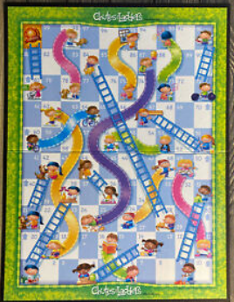
P5 – Chutes and Ladders

CS1010
Project Name: lastname_chutes.py

Program assignment:
Your next assignment will be to complete a program to play the children's game Chutes and Ladders. The game is played on a board which contains 81 squares, numbered 1 through 81. Each player starts at position 1 and throws one die to determine the number of squares to move on that turn. The first player to reach (or exceed) square 81 wins the game. “Chutes” and “Ladders” exist at various points on the board to enhance play. If a player's token lands on a chute, they "slide" down it and move backward on the board, but if they land on a ladder, they "climb" it and move forward on the board. The beginning and ending locations of each are:

Chutes - move back Ladders - move forward

top bottom bottom top
11 4 8 16
15 7 12 27
30 21 28 39
44 31 33 46
58 43 48 55
64 54 59 75

Download the chutes.py file and add your information to the top of the file. You will then modified the code given in chutes.py file that plays the game with two players. The players’ names will be entered by the user using two input statements. Players will start at position 1, and terminating when one player has reached square 81 or beyond. I have supplied code that will output a table indicating the player, the turn (move number), the value of the die, and the position after the move; a header for the table that will be printed at the start of game; and a line of dashes that will separate each set of turns. The winning player and the player’s position will be printed BY YOU at the end.

Method:

I have created a scenario similar to zxbooks where you will add the missing code to create your solution. Please see the #TODO comments through the program. You will see #???? everywhere you will need to add your code.

Sample input:
Enter Player 1: 001
Enter Player 2: 456

Sample output:

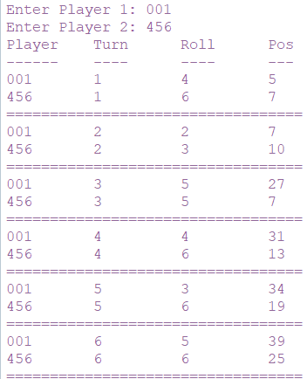
(And so on until one player reaches or exceeds position 81.)
It will then display.
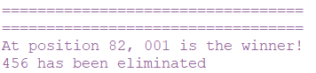

Program Documentation & Style:
1. Your program should include two types of comments:
a. Header Comments at the top including lines with:
- Your name, course name, and class time
- Program file name and due date
- A sentence or two explaining the purpose of the program
b. In-line comments: There should be an in-line comment for each main step in your program. In general, this means a comment with each group of statements that handles the input, the processing and the output steps of your program.
2. Use meaningful identifier names
3. Include clear prompts for the user about entering the data.
4. Include clear descriptions of the results when you display them

Submit:
- Your python file - chutes.py
- You will not turn in output. NO OUT SUBMITTED THIS TIME

